**Version Control Documentation**

1. <https://github.com/LukeStanbridge/VersionControl.git>
2. <https://github.com/LukeStanbridge/VersionControl/commit/512630f5b183d6b38054ad23fb034835fc4b128f>
3. <https://github.com/LukeStanbridge/VersionControl/pull/1>
4. Git is the most commonly used version control system. Git tracks the changes you make to files, so you have a record of what has been done, and you can revert to specific versions should you ever need to. Git also makes collaboration easier, allowing changes by multiple people to all be merged into one source. So regardless of whether you write code that only you will see, or work as part of a team, Git will be useful for you.

GitHub does offer private repositories, but this isn’t necessarily perfect for many. For high value intellectual property, you’re putting all of this in the hands of GitHub as well as anyone who has a login, which like many sites [has had security breaches before](https://www.theinquirer.net/inquirer/news/3031566/github-bug-exposed-user-passwords-in-plaintext) and is targeted constantly. It is often better than nothing, but it’s not perfect. In addition, some clients/employers will only allow code on their own secure internal Git as a matter of policy.

Some of GitHub features, as well as features on other online repositories, are locked behind a paywall. If you have a large team, this can add up fast. Those who already have a dedicated IT team and their own internal servers are often better off using their own internal git for cost reasons, but for most the cost isn’t outrageous.

1. The cost and security of building games with multiple people working simultaneously on the same project.
2. The problem is for game development teams of all sizes.
3. Businesses need to decide if cost/security of using GitHub out ways the time and money of setting up and maintaining an internal Git.
4. Beneficial for teams to work together on a project through Git rather than all have individual copies of a project and merge everything manually.
5. - Time efficient.

* Ideal for projects of all sizes.
* Offers the most flexibility for project work.
* Easy to work from home.

1. - Potential costs depending on using GitHub paywall features or setting up internal Git

* Depending on certain IP and privacy restrictions, security may be a factor.
* Learning curve for developers if unfamiliar.

1. <https://bodhizazen.net/git-advantages-and-disadvantages/>

<https://blog.desdelinux.net/en/github-vs-gitlab/?utm_source=destacado-inside#Ventajas_y_desventajas_de_GitLab>

Full Commit History

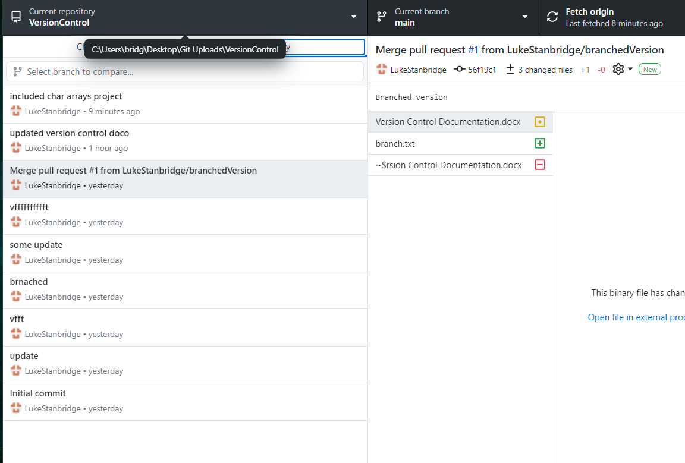

* Added character arrays exercises project from course content into my version control repo